MySQL Assignment

Joins and Union

Q) Consider the Country table and Persons table that you created earlier and perform the following: (1)Perform inner join, Left join, and Right join on the tables. (2)List all distinct country names from both the Country and Persons tables. (3)List all country names from both the Country and Persons tables, including duplicates. (4)Round the ratings of all persons to the nearest integer in the Persons table.

A)

use world_population;

select * from country;

desc country;

select * from persons;

desc persons;

-- inner join

select persons.fname, country.country_name, persons.rating

from persons

inner join country on persons.country_id = country.id;

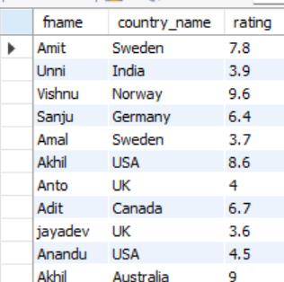

-- left join

select persons.fname, country.country_name, persons.rating

from persons

left join country on persons.country_id = country.id;

-- right join

select persons.fname, country.country_name, persons.rating

from persons

right join country on persons.country_id = country.id;

-- List all distinct country names from both the Country and Persons tables

select distinct country.country_name from country

union

select distinct persons.country_name from persons

join country on persons.country_id = country.id;

-- List all country names from both the Country and Persons tables, including duplicates

select distinct country.country_name from country

union all

select distinct persons.country_name from persons

join country on persons.country_id = country.id;

-- Round the ratings of all persons to the nearest integer in the Persons table:

select id, fname, lname, country_name, rating from persons;

select id, fname, lname, country_name, round(rating) as Rounded_Ratings from persons;

